Quick Reference Guide
RPS Digital Viewer v1.4

Jake Chapple
Raritan Photographic Society
October 22, 2010

Table of Contents

Installation 2
Competition Workflow 2
Importing Images Automatically 4
Importing Images Manually 5
Main Window 6
Main Menu 9
Slide Show Mode 12
Thumbnail Mode 13
Uploading Scores to the Web Server 14

Installation

Once installed, the application consists of just two files; the executable program (RPS Digital Viewer.exe) and its database (rps.mdb).

The program is designed to run on a Windows XP, Windows Vista or Windows 7 laptop with a screen resolution of 1024x768. It can be run on a Windows 2000 machine, however, you’ll have to make sure the .NET Framework 1.1 is installed and the version of Microsoft MDAC is 2.6 or greater.

To install the application:

- Download the installer program from the RPS web site and save it to your desktop.
- Launch the installer program and the wizard will guide you through the installation.
- When installation is complete
  - The program will be stored in C:\Program Files\RPS
  - There will be a shortcut to the program on your desktop
  - The program will assume that the folders of competition images are stored in C:\Program Files\RPS\Photos

Competition Workflow

The program implements a workflow that is specific to the RPS Competition Rules (see http://www.raritanphoto.com/RPS/competitions/rules.html).

- The first step in the workflow is for the club members to submit their images and for the Digital Chair to import them into the program’s database. This is done in one of two ways:
  - The members email their images to the Digital Chair and s/he imports them manually.
  - The members upload their images to the club web site and the Digital Chair downloads and imports them automatically.
Both the manual and automatic import procedures are described in separate sections below.
- After all the competition images are imported, competition score sheets can be printed if desired (Reports ► Score Sheet).
It may seem like an anachronism to record the scores digitally and to write them by hand on paper. The hand written score sheets can be useful independent documentation when arbitrating disputes over posted scores.
- At the competition meeting, the laptop is connected to the digital projector.
- The program is launched and a competition is loaded by selecting the Competition Date, Medium and Classification on the main screen.
- The program is switched to slide show mode and the judge makes the first pass through the images, assigning a score to each.
- The slide show mode is exited and the main window shows the total number of awards to choose. It also shows how many awards to pick from the 7s, 8s and 9s.
- To pick awards from the 7s, the “7” button is clicked and the program displays thumbnails of all the images that received a score of 7. The judge picks the award winners and the thumbnail mode is existed.
- Step 7 is repeated for the 8s and 9s until all awards have been assigned.
- After all awards have been chosen, the “Awards” button is selected and the slide show is launched again. The Digital Chair steps through each image in order and announces the title and photographer’s name for each one.
- Following the competition, the Results Report is printed for each competition and published accordingly.

Importing Images Automatically

- The club members log on to the RPS web site and upload their digital entries into the appropriate competitions.
- After 8:00pm on the Tuesday before a competition meeting, the Digital Chair logs on to the RPS web site and closes the upcoming competitions. Competitions are closed by:
  - Select the Competitions Tab on the RPS home Page
  - Select Admins Only ► Competitions from the left hand menu.
  - Login
  - Check the checkboxes for the competitions to be closed.
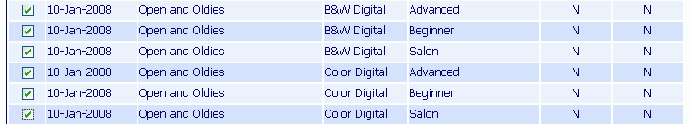

  - Click the button at the very bottom of the screen.
- Connect the laptop to the Internet and launch the RPS Digital Viewer program.
- From the main menu, choose Competitions ► Download Images from Server…
- On the Download Competitions dialog, enter
  - Your RPS web site username in the Username field
  - Your RPS web site password
  - Select the date of the competitions to download. There is usually only one date in the list.
  - If you want to download the images for just Digital competitions, or just Print competitions, uncheck the corresponding checkbox.
  - Enter the path of the root folder where the .jpg files are to be stored on the laptop hard drive. The default path is C:\Program Files\RPS\Photos
Each competition of images will be stored in a separate subfolder within this root folder.

Importing Images Manually

- Club members email their .jpg files, as attachments, to the Digital Chair Person in advance of the competition date. The attachments must conform to a file naming convention title+maker.jpg e.g. “Flowers in the Valley+Jake Chapple.jpg”. Also, the images must have been resized to be no bigger than 1024x768.
Note: If an image is bigger than 1024x768, the excess is cut off. This program does not resize images to fit the screen.
This is not a problem when images are downloaded and imported automatically from the server. The server has already resized the images.
- The Digital Chair stores the attachments in individual competition folders on the laptop as they are received by email. You are free to choose whatever folder structure you like for storing the images. The folder structure in the following screen snapshot has proven to work very well.

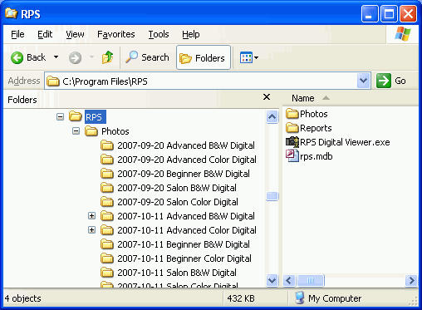

- Just prior to the competition, the Digital Chair runs the program and imports a folder of new competition images into the database. (Competitions ► Catalog a Folder of Images). Repeat this step for each folder of new competition images.
- If there is a last minute entry received, that single file can be imported with Competitions ► Catalog Individual Images

Main Window

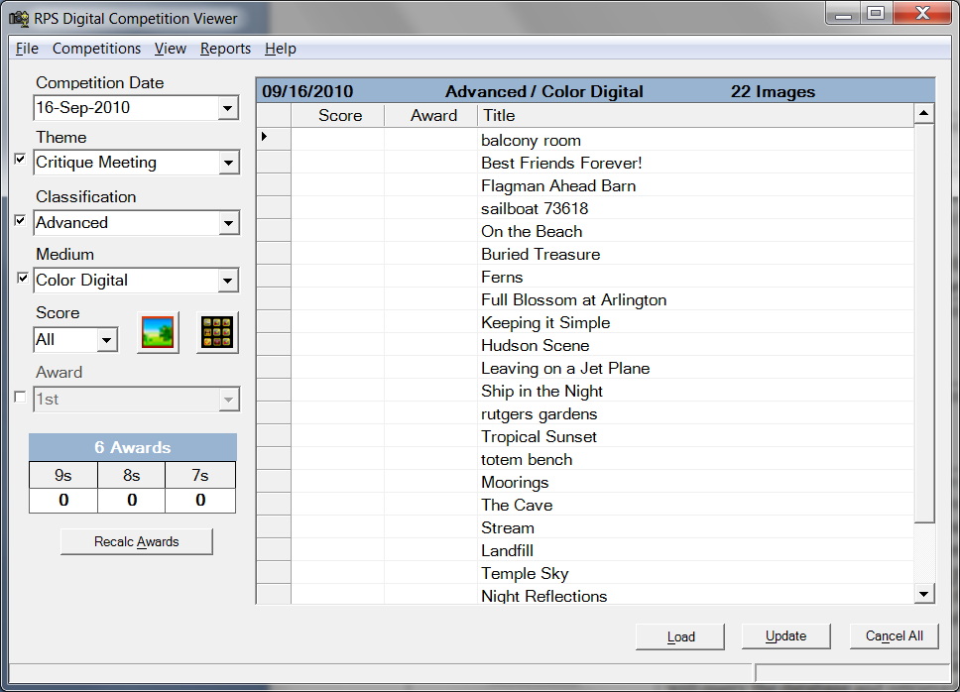

During the actual competition meeting, everything is managed using the various controls on the main window. The following table summarizes the function of each control.

Controls on the Main Window
The six dropdown lists are filters that control which images are retrieved from the database. These filters are additive. Each active filter combines with the ones above it to further narrow down the list of images selected from the database.
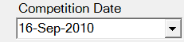 | Find all the images for the selected date.
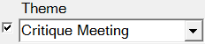 | If there are multiple themes being judged on the same date, only choose images that match the selected theme.  This filter is turned off if the checkbox is cleared.
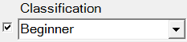 | Only choose images for the selected skill level.  This filter is turned off if the checkbox is cleared.
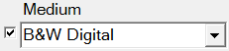 | Choose images of a particular medium (competition type)  This filter is turned off if the checkbox is cleared.
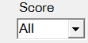 | This list selects images that have received a specific score. Unlike the other filters, this filter is turned off by selecting “All”
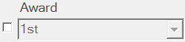 | The Award filter is turned off by default. It is rarely used. Checking the checkbox turns on the filter so you can choose all the images that received a particular award.
Slide Show button  | The Slide Show button switches to the slide show mode. Those images displayed in the grid will be displayed in the slide show. By default, the slide show starts at the first (top) image in the main grid. You can start the slide show at a different image by first selecting the desired starting row in the grid and then clicking the Slide Show button. Select a row by clicking in the left hand (grey) column of the row.
Thumbnails button 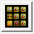 | The Thumbnails button launches the thumbnails screen for assigning awards to images.
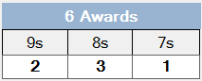 | The Awards table shows that total number of awards needed for the current competition being judged. It also shows how those awards are to be distributed across the 9s, 8s and 7s.  The table is updated when exiting the Slide Show.  In this example, 1st and 2nd place will be awarded to the 9 point images, 3rd place and two HMs go to the 8 point images and one HM must be selected from the 7 point images.
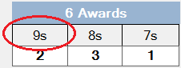 | Awards are assigned with the thumbnail viewer. Click the column heading of the 9s column to automatically select the 9 point images and launch the thumbnail viewer.  This is the same as selecting “9” in the Score dropdown list and then choosing View ► Thumbnails
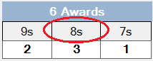 | Click the column heading of the 8s column to select awards from the 8 point images.
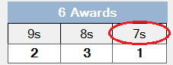 | Click the column heading of the 7s column to select awards from the 7 point images.
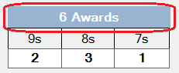 | Click the title of the Awards table to select those images in the competition that received an award, or that received a score of 8 or more, but no award. This is used, after all the awards have been chosen, to announce the names of the winning photographers.
 | This is rarely used any more. Click this button, if you need to recalculate the distribution of awards between 9s, 8s and 7s.
 | This is rarely used any more. Clicking the Load button will query the database and retrieve those images that match the competition defined by the Competition Date, Theme, Classification, Medium, Score and Award dropdown lists
 | You can change the values of the sores and awards on the main grid just like you change values in a spreadsheet. These changes are only made in memory. To commit the changes to the database, you must click the Update button.
 | If you make a mistake and want to discard any changes you made in the main grid, click the Cancel All button.

Main Menu

This section briefly describes the items on the main menu. These menus are usually used before and after a competition meeting. The menus are not used during the actual competition judging.

File ► Preferences … | Here you can set several preferred locations  - The root folder into which the .jpg files will be copied as they are imported. Each competition is stored in a separate subfolder within this root folder. The default root folder is the folder where the executable is stored.  - The path and file name of the MS-Access database used by the executable. The default file name is “rps.mdb” and it’s default location is the same folder as the executable  - The folder where the score sheet reports and result reports are written.  - The host name of the appropriately configured web server.  - The virtual directory on the web site that contains the PHP scripts.  - The camera club name to appear on the first line of the splash screen at the beginning of each slide show.  - The number of judges providing separate scores for each image.
File ► Exit | Exit the program
Competitions ► Catalog Individual Images… | Import an individual .jpg file(s) from disk. The file name must be of the format  <Title>+<Maker_Name>.jpg  e.g. Mona Lisa+Jake Chapple.jpg  (there must be one and only one Plus sign in the file name)  The subsequent dialog box allows you to classify the image(s) to be imported. Enter values for:  - The date of the competition  - The competition theme e.g. “Landscapes”  - Is it B&W or color, digital or print  - The maker’s skill level  - Click the Browse button to select one or more individual .jpg files.
Competitions ► Catalog a Folder of Images … | Import a whole folder of .jpg files. All the .jpg files in the folder must conform to the naming convention above. Also, there is an assumption that all files in the folder are to compete together in the same competition i.e. same date, medium and classification.
Competitions ► Download Images from Server … | Download competition images from the RPS web server. In the subsequent dialog, you specify:  - Your RPS digital competitions username. The user account must have “Digital Admin” privileges on the web site.  - The password for the account  - Choose the date of the competitions to download. Only competitions that are “Closed” and not “Scored” will appear in the list.  - Check the Digital and Print checkboxes to download images from those respective competitions. Uncheck the Print checkbox to only download images for Digital competitions.  - The folder into which the downloaded .jpg files will be placed. The default value is the root folder specified in File -> Preferences.
Competitions ► Upload Scores… | Upload scores to the RPS web server. Enter values for  - Your RPS username (it must be a Digital Admin account)  - Your RPS password  - The date of the competitions to upload. There is usually only one date to choose from.  - Uncheck any of the checkboxes for competitions you don’t want to upload.
Competitions ► Create Best Of… Competition… | This option searches the database and gathers all the award winning images, between a range of dates, and automatically creates a “Best of …” competition. By adjusting the data range it could be a “Best of Month” or a “Best of Year” competition. No .jpg files need to be imported. The dialog box allows you to specify:  - The earliest date to include in the search  - The latest date to include in the search  - The date the Best of … competition will be held  - Choose a theme to apply to this new competition
View ► Slide Show | Start the slide show just as if you had clicked the Slide Show button
View ► Thumbnails | Launch the thumbnail view. This the exact same function as clicking the Thumbnails button.
Reports ► Score Sheet | This menu item will launch your default web browser and display a score sheet for those images currently in the main grid. The score sheet can be used to manually record scores and awards during judging. You typically print score sheets before the competition.
Reports ► Results Report | The Results Report is similar to the score sheet report except that is has the scores and awards printed on the report. It is printed after the competition is over.
Help ►About | Displays the current version number of the program.

Slide Show Mode

When you launch the slide show it completely takes over the screen so you don’t have any menus or buttons to control the program. The slide show is controlled exclusively with keys on the keyboard.

The “Secret” Keystrokes for Driving the Slide Show
Esc | Exit the slide show and return to the main window
Home | Jump to the first image in the slide show
Down Arrow,  Right Arrow,  Page Down | Move to the next image in the slide show
Up Arrow,  Left Arrow,  Page Up | Move to the previous image in the slide show
End | Jump to the last image in the slide show
1,2,3,4,5,6,7,8,9 | Assign the corresponding score to the current image
F1 | Award “1st” place to the current image
F2 | Award “2nd” place to the current image
F3 | Award “3rd” place to the current image
F4 | Award an “HM” to the current image
Delete,  Back Space | Erase any score or award that has been assigned to the current image.
C | Clear all the popups that could be obscuring the image i.e. the score/award and the bottom status bar.
S | The status bar at the bottom of the slide show can be in one of three different states:  - Invisible  - Visible – displays the title, score, award  - Visible – displays the title, photographer name, score and award.  Pressing the “S” key toggles the status bar through each one of these three states.

Thumbnail Mode

Version 1.2 of the program introduced a thumbnail view designed for choosing awards after all the images have been assigned a score. Thumbnail mode is invoked by selecting one of the “9”, “8”, “7” radio buttons on the main screen and then clicking the Slide Show button. Like the side show mode, the thumbnail mode is also controlled completely by keystrokes. The keystrokes for the thumbnail mode are (mostly) a subset of the slide show keystrokes.

The “Secret” Keystrokes for Driving the Thumbnail View
Esc | Exit the slide show and return to the main window
Right Arrow | Move one image to the right
Down Arrow | Move down to the next row
Left Arrow | Move one image to the left
Up Arrow | Move up to the row above
F1 | Award “1st” place to the current image
F2 | Award “2nd” place to the current image
F3 | Award “3rd” place to the current image
F4 | Award an “HM” to the current image
Delete,  Back Space | Erase any award that has been assigned to the current image.
Z | Zoom the currently selected thumbnail to show the full size image. Pressing the Z key again while the full size image is displayed returns you to the thumbnails.

Uploading Scores to the Web Server

When the competition is over, the scores and awards can be automatically uploaded to the web server. The upload procedure is:

- Connect the laptop to the Internet and launch the RPS Digital Viewer program.
- From the main menu, choose Competition ► Upload Scores…
- On the Upload Scores dialog, enter:
  - Your RPS web site username in the Username field
  - Your RPS web site password
  - Select the date of the competitions to upload. There is usually only one date in the list.

